TNL will send professional development information to HRMS. LEAs can choose from four views to review data and can choose whether to ignore or update/add CEU data that has been imported.

NOTE: This functionality is optional. An LEA can choose to do nothing and there is no impact to HRMS.

The user is presented with the following views:
- Duplicates for Review – this will be expanded by default if duplicates exist. Records from TNL that match existing records in HRMS based on the Employee UID, Course Code and Completed Date are displayed.
- CEUs by Course Code – Non-duplicate records received from TNL that are grouped by the Course Code. These same records appear ‘by Employee’ and will disappear from there once resolved.
- CEUs by Employee - Non-duplicate records received from TNL that are grouped by the employee. These same records appear ‘by Course Code’ and will disappear from there once resolved.
- Rejected CEUs – When users ignore/reject records during the review process, they appear here. Users only need to use this section when searching for records that may have been rejected in error.

To find the TNL CEU Data Import page in HRMS, from the HRMS Home page, click on Continuing Ed then TNL CEUs

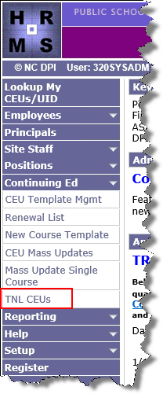
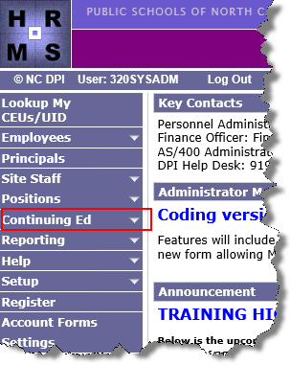

The TNL CEUs Data Import page displays
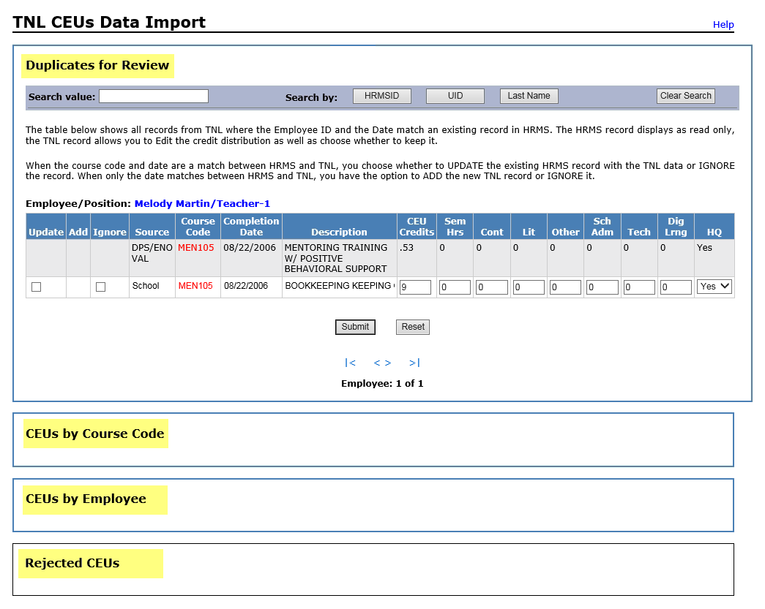

Duplicates for Review
By default, if records exist the Duplicates for Review section will be open. Anything that is a duplicate of a record already in an employee file will display in this area. Displays one set of duplicate records per person, per screen.

There are two types of duplicate groupings that will be displayed.
- A “true” duplicate will show with the Course Code in red if the following are an exact match.
- Employee UID
- Course Code
- Completed Date
Users have the option to review the duplicate and either Update or Ignore the record.

- A duplicate that matches on just the following fields.
  - Employee UID
  - Completed Date
Users have the option to review the duplicate and either Add or Ignore the record.
True Duplicates
These records are matching on Employee UID, Course Code and Completed Date. Because these records are already in the system, users do not have the option to ADD. These records can only be Updated or Ignored.

Update Record
If choosing Update, the information will be updated in the employee record. Use the instructions below to update an existing record.

- Enter check in Update checkbox of the desired record(s)
- Update the credit distribution, if needed
- Click Submit. The new information will be updated in the employee record.
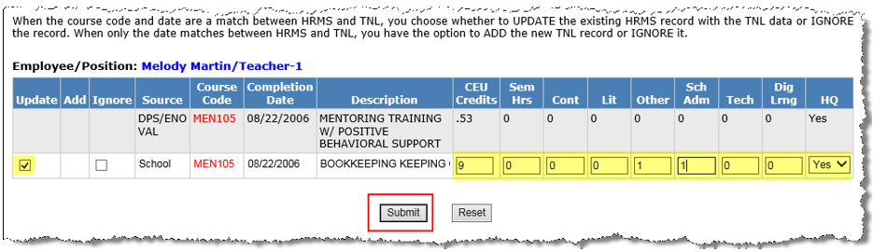

Click Reset to clear the checkbox and any information that has been entered in the distribution areas, if needed.

Ignore Record
If the record is a duplicate and does not need to be updated, the user can choose to ignore the displayed record. If Ignore is selected and the record is a true duplicate, the ignored record will not be displayed again.

Important: If it is determined a record was ignored in error, the user will need to contact DPI.

Use the instructions below to ignore a record.

- Enter a check in the Ignore checkbox for each record to be ignored
- Click Submit
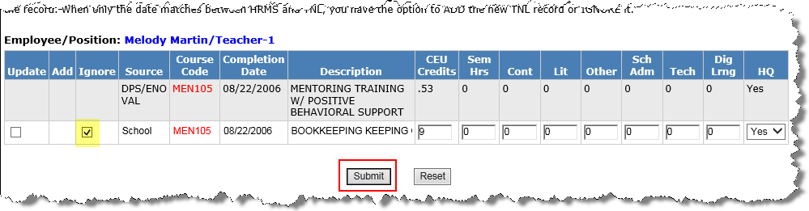

Click Reset to clear the checkbox and any information that has been entered in the distribution areas, if needed.

Duplicates

These records are only matching on Employee UID and Completed Date. They are not ‘true’ duplicates because the Course Code does not match. Because these records are not ‘true’ duplicates, users have the option to Add or Ignore the record.

Add Record
If choosing ADD, the information will be added to the employee record. Use the instructions below to add CEU information to the employee record.

- Enter check in ADD checkbox of the desired record(s)
- Update the credit distribution, if needed
- Click Submit. The new information will be added to the employee record.

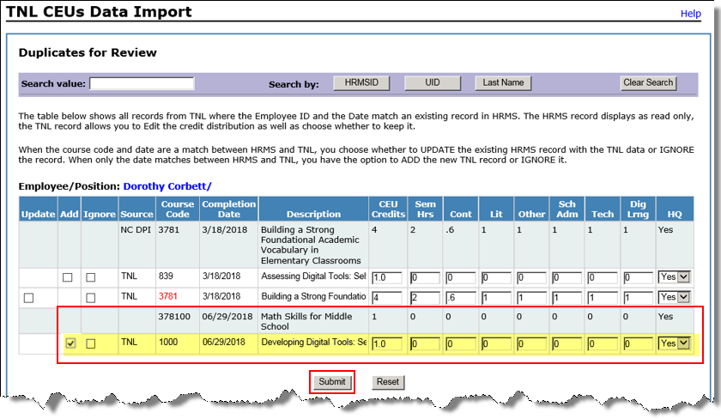

Click Reset to clear the checkbox and any information that has been entered in the distribution areas, if needed.

Ignore Record
If the record is a duplicate and does not need to be updated, the user can choose to ignore the displayed record. If Ignore is selected, the ignored record will not be displayed again in this section.

Important: If it is determined a record was ignored in error, the user will need to contact DPI.

Use the instructions below to ignore a record.

- Enter a check in the Ignore checkbox for each record to be ignored
- Click Submit

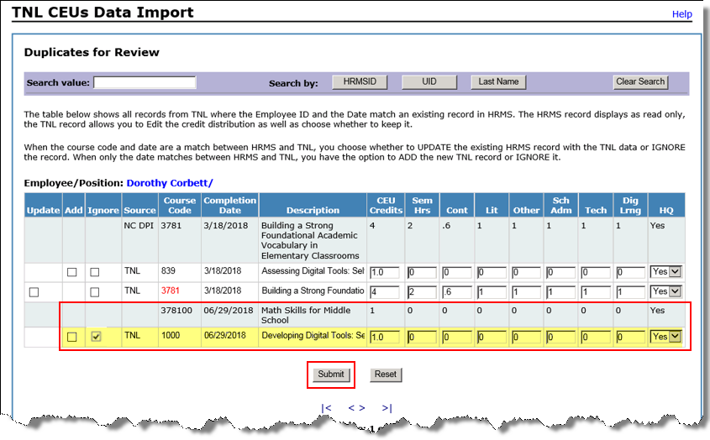

Click Reset to clear the checkbox and any information that has been entered in the distribution areas, if needed.

CEUs by Course Code
Allows the user to view CEUs for multiple employees by course code. Displays one course grouping by default. A course grouping consists of a roster of all employees assigned to the same course code and date.

- Enter the desired course code in the Search Value
- Click to Search by – choose one
  - Course Code – to search for all records of a course code regardless of date
  - Date – to search records of a course code by date
To clear the values and start over, click Clear Search

- Select the appropriate License Categories if content credit should be assigned
NOTE: License Categories show up only when there is a non-zero value in the Content Credits field.
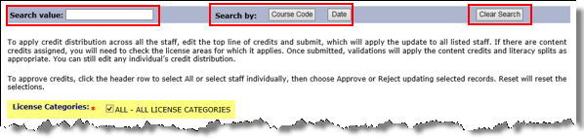

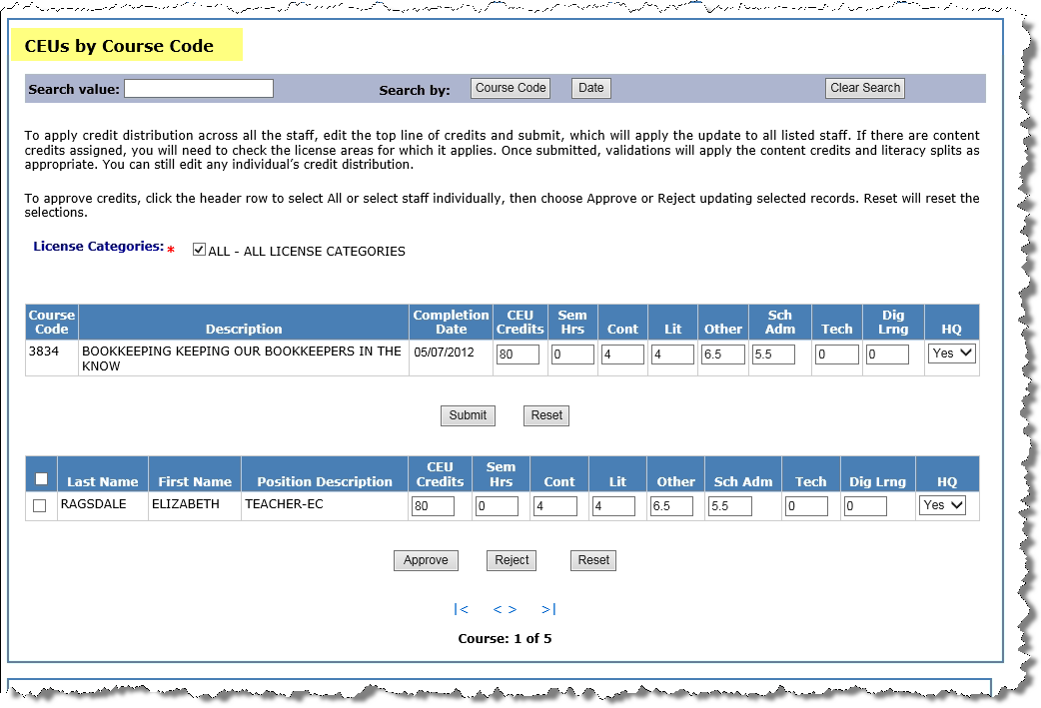

- Review the records and edit distribution, if needed.
  - To update distribution values to be the same for all records, edit the values in the top line then click Submit to apply credit distribution to all records displayed. Click Reset to reset to original values.
  - To update distribution values per employee, edit the values in each record.

- To apply credit, enter a check in the checkbox(es) of record(s) to be updated then click Approve.

To approve all records at once, click the header row. The user can click Reset to reset the values.

Note: A Reject button is available. This will flag all selected records in the course grouping as denied and the records will be moved to the REJECTED CEUs section.

CEUs by Employee
Allows the user to view records by individual employee. Displays up to 10 records per page. Users can search by HRMS ID, UID or employee Last Name.

Note: If searching by last name, records for all employees with the searched name will be displayed.

- Enter desired value in Search value field (Last Name, HRMS ID or UID)
- In Search by field, click to perform the search based on the value entered in the Search Value field (e.g. HRMSID, UID or Last Name)

Note: To clear the search fields and start over, click the Clear Search button

- Review, and edit if needed, the credit distribution fields for each record
- To approve or reject specific records, enter a check in the checkbox for the desired records, then click Approve or Reject
  - To approve or reject ALL listed records, enter a check in the checkbox in the header row, then click Approve or Reject
Note: Rejected records will be flagged and will remain in the staging table.

- Click Reset to clear changes entered in distribution fields
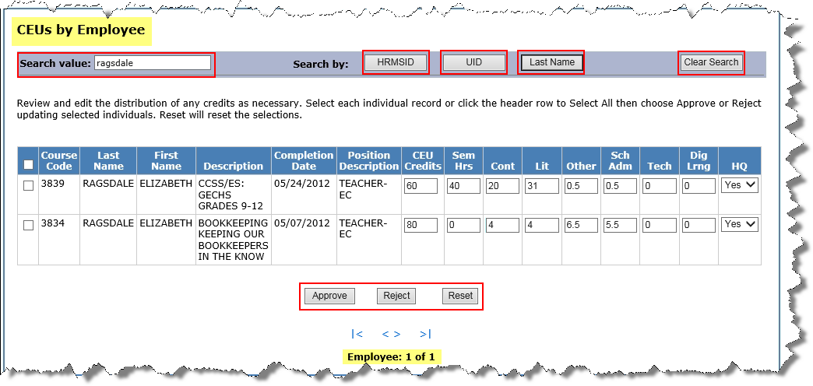

Rejected CEUs
Allows the user to view records previously rejected. Users can search by the following:
- HRMS ID
- UID
- Last Name
- Course Code
- Date
Important: If a record that is a true duplicate was previously ignored, the ignored record will not be displayed again. If the record was ignored in error, the user will need to contact the DPI HRMS Help Desk.

- Enter the desired Search value
- In the Search by area, click the appropriate button to match the search value (e.g. If enter ‘Smith’ in Search Value, select Last Name in Search by)
- Review and edit, if needed, the credit distribution for each record
- Enter a check in the checkbox(es) of the record(s) to be updated
- Click Approve to approve and submit the changes or Reset to reset values

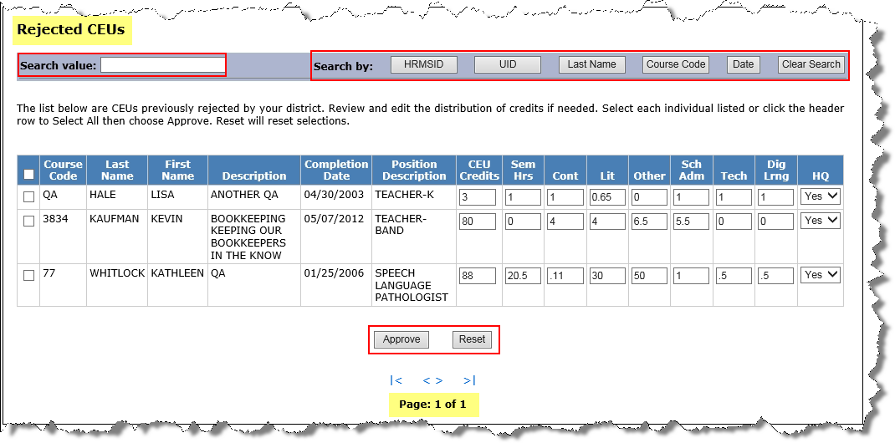

Note: To select all records in the section, click the checkbox in the column header row.

